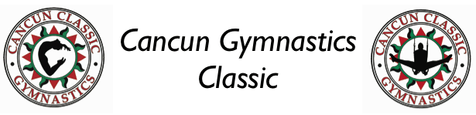

CANCUN GYMNASTICS CLASSIC
JANUARY 6 – 9 , 2022

Club
Registration Form

Club_____________________________________________________

Address____________________________________________________

City ____________________State ____Zip__________________

Head Coach _______________Contact Person_____________________

Office #______________Cell #_____________Fax #___________

E-Mail___________________________________________

Non-Refundable deposit:
Clubs $500.00

Payment by:

Attached Check_____ Visa___ Master Card___ Exp date_______

Name on card______________________________________

Billing address________________________________________________

Card Number____________________ Security Code:______________

Signature________________________

Please send you registration form and payment to:
Classic Events USA
2804 Pinehurst Circle
Ames, IA 50010
Email to; cancunclassic@yahoo.com
WWW.CLASSICGYMNASTICSEVENTSUSA.COM

